Gorecki, Nicholas

Assignment 7

GitLab Repo: git@gitlab.com:Gorecki.Nicholas/as7-goreckinj.git

All Tests Passing:

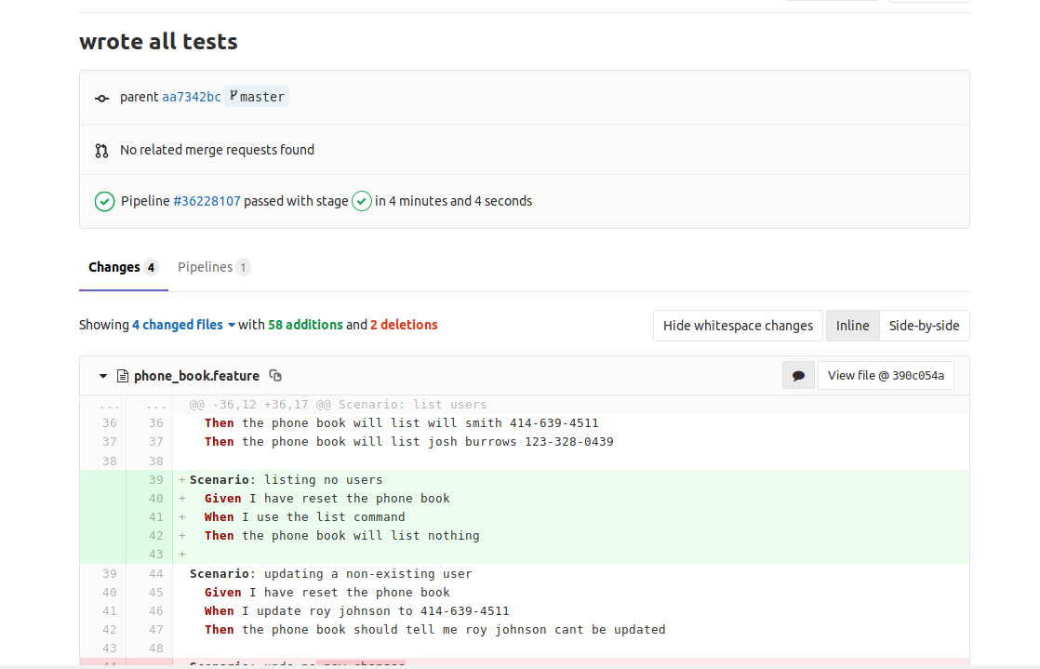

Modifying error with History.java file

-Error made: Changed peek() to pop() in nextToUndo() method, line 38, for done_cmds stack

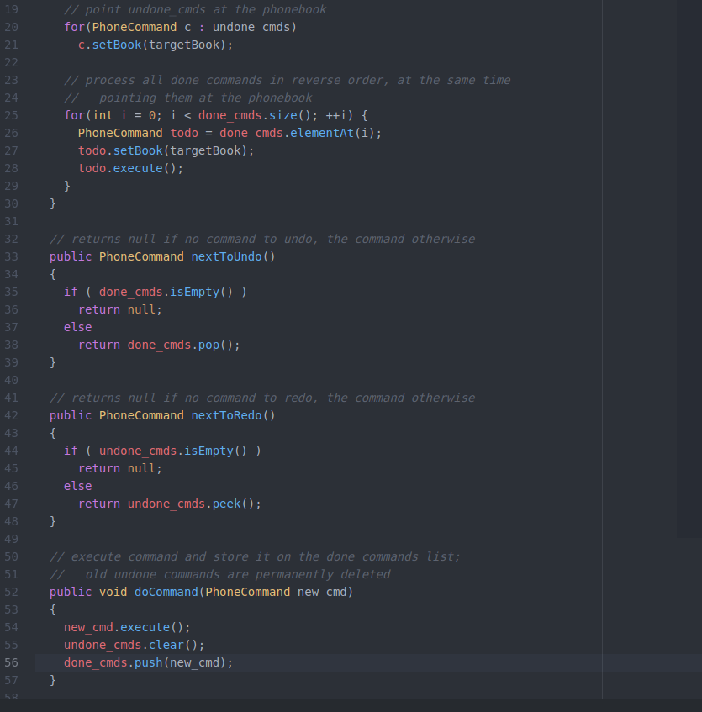

Output from pipelines (I couldn’t capture the whole thing in one image, but you can see there are empty stack exceptions and unexpected outputs from tests):

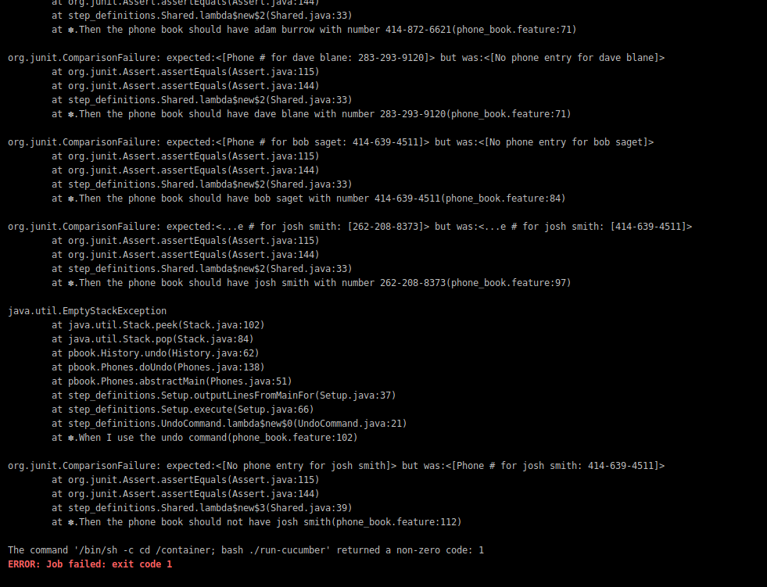

Modifying error in features file:

-Error made: Changed line 97 from expecting the phone book to have josh smith to expecting the phone book to NOT have josh smith

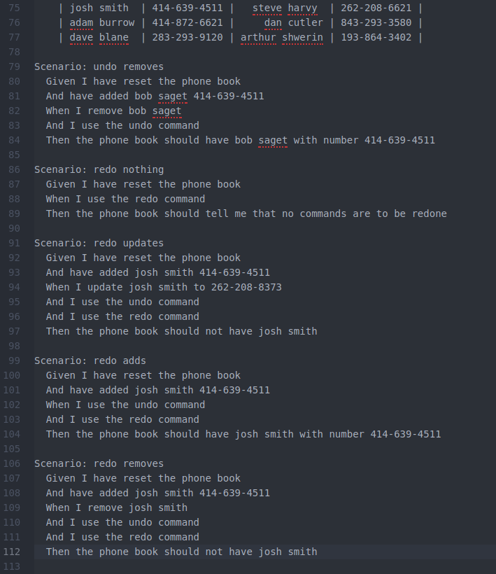

Output from Pipelines:

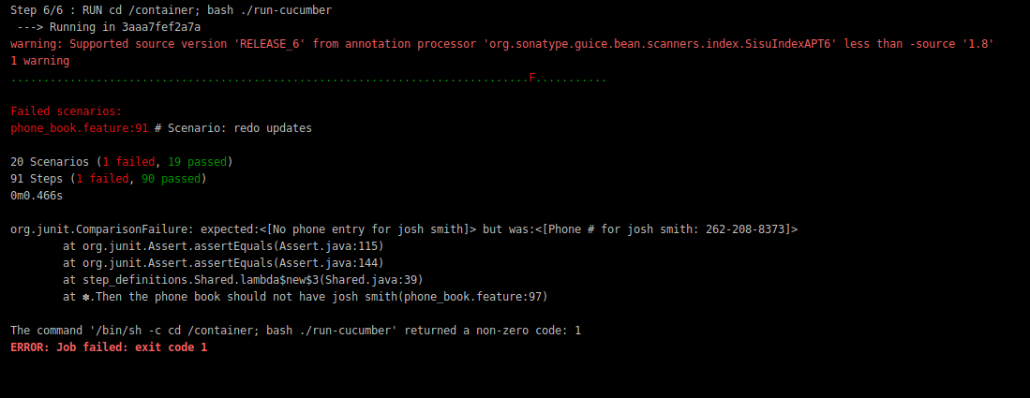

Pipelines Log after pushing all working tests as last commit:

